### **Lab - Advanced Summary Statistics**

****Shaik.Hameeda Parvin****

****G34 PYTHON****

1. Identify all duplicate cases using ****prof****. Using all observations, find the average and standard deviation for ****age****. Repeat the analysis by first filtering the data set to include one observation for each instructor with a total number of observations restricted to 94.

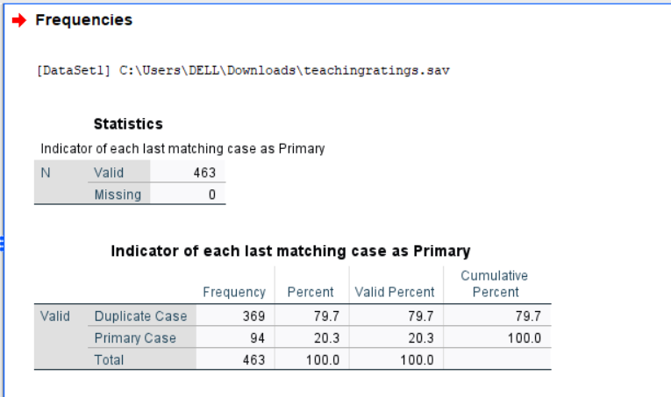

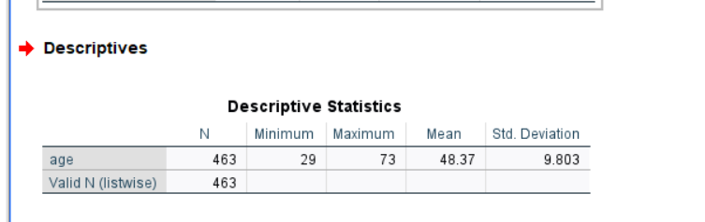

|  |  |  |  |
| --- | --- | --- | --- |
|  | | | |
| **Descriptive Statistics** | | | |
|  | N | Mean | Std. Deviation |
| age | 94 | 47.55 | 10.257 |
| Valid N (listwise) | 94 |  |  |

1. Using a bar chart, demonstrate if instructors teaching lower division courses receive higher average teaching evaluations.

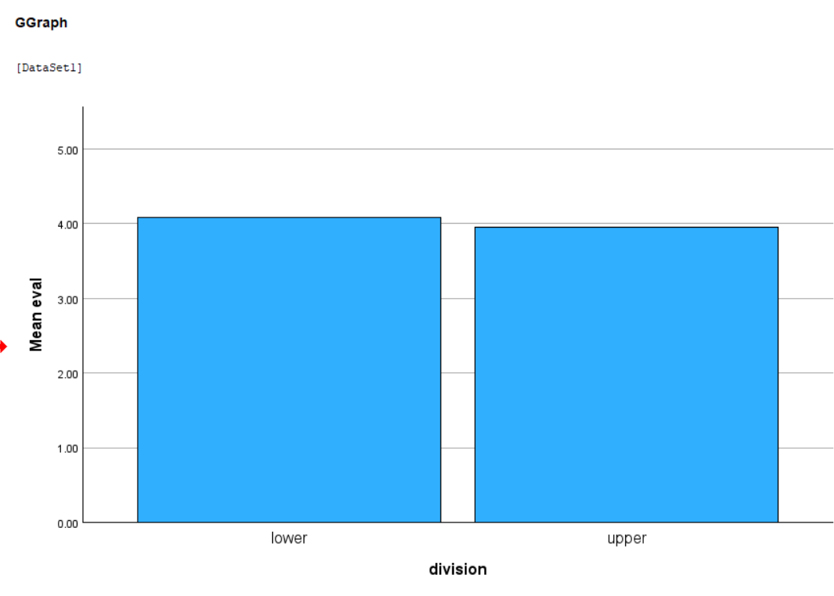

1. Using **gender** differentiated scatter plots, plot the relationshipbetween **age** and **eval**.

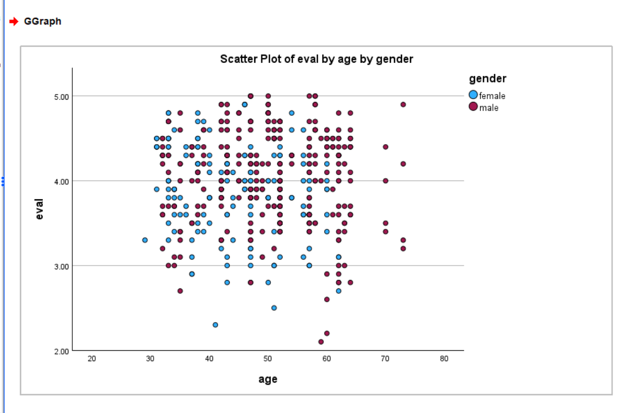

1. **Box Plot of Beauty Differentiated by Credits**

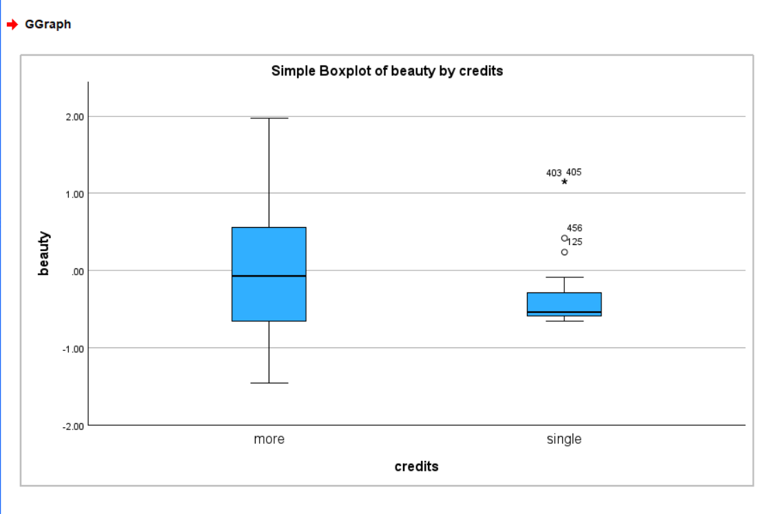

1. Using OLAP cubes reproduce the following table.

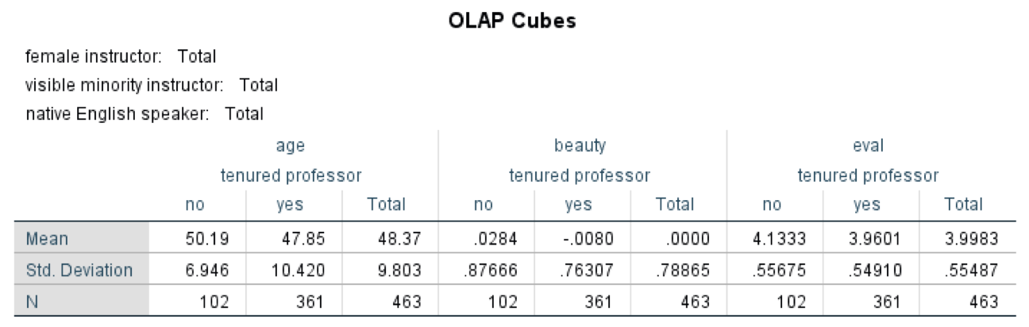

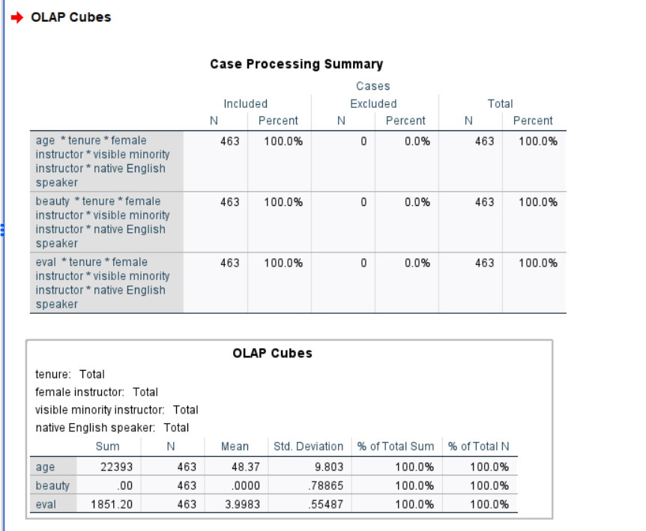

6.Is there a systematic relationship between **gender** and **division**? Produce a cross tabulation between the two with percentages to answer this question.

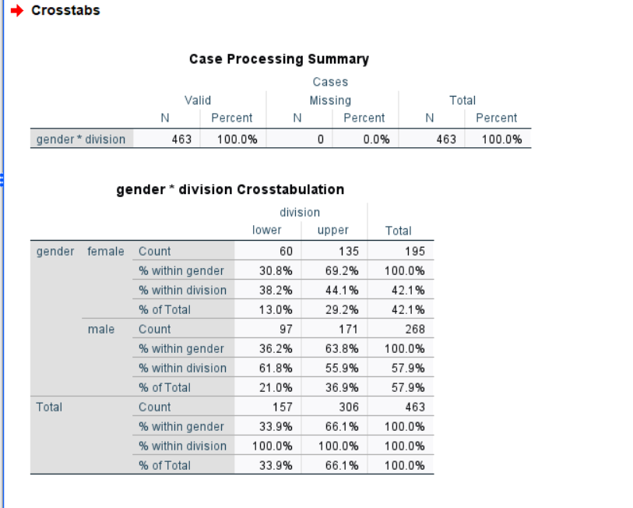

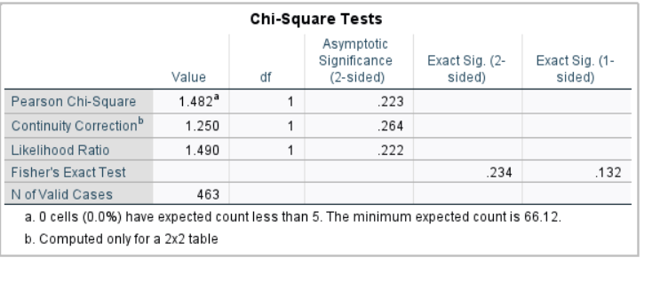

the **Pearson Chi-Square test (χ²(1) = 1.482, p = 0.223)** indicates that this difference is **not statistically significant**.  
Therefore, we **conclude that there is no systematic relationship between gender and division**

**7** Are **beauty** and **age** correlated? Using Pearson Correlation to answer this question.

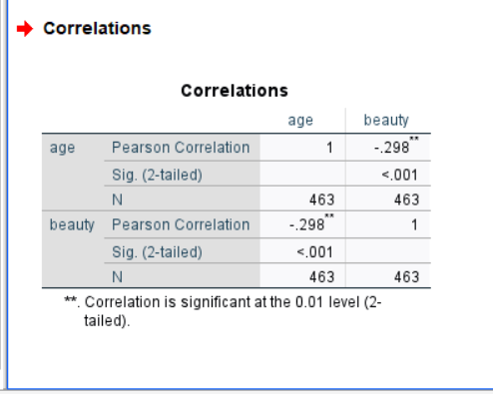

There is a **significant negative correlation** between age and beauty (r = -0.298, p < .001).  
As the **age of instructors increases**, their **beauty ratings tend to decrease**.  
The relationship is statistically significant but **moderate in strength**.